July 2022

How can learning in, learning about, and learning for the natural environment help our health and well-being?
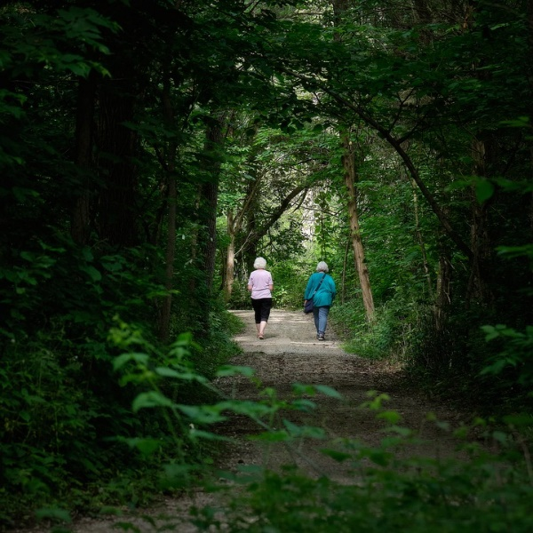
In 2008, the New Economics Foundation published the study ‘5 ways to well-being’ study, which identified evidence-based actions to improve well-being. Each step has synchronicity with being in nature and the natural environment can act as a natural health service providing multiple benefits for physical and mental well-being as summarised on our poster here.

1 – Give
Nature is amazing. We need nature. It underpins our very existence but it’s very easy to take nature for granted. It’s important to remind ourselves at every opportunity that the decisions we make and the actions we take can support both nature and us. Generous behaviour is known to increase happiness, so go on, take practical action for nature. From litter picking to creating a small pond in a bowl at your settings’ grounds, help nature thrive by giving something back.

2 - Learn
Learning new things can increase confidence and be fun at the same time. Let nature be your teacher, join your learners on an outdoor learning journey and increase their emotional connection to nature. Can your learners identify the trees you’ve got in your settings’ grounds? When you’ve ticked that off your list, turn your attention to flowers, birds and so on.

3. Be active
The single best thing that we can do to improve our overall health is exercise! And we are not talking anything complicated or intense here. Regular physical activity has many benefits to health, including mental health and well-being. With children and young people now living a lot of their lives online with more time given to screen time, we need to encourage learners to ditch the gaming controller, unplug and get active.

People who are physically active have up to a 50% reduced risk of developing major chronic diseases such as coronary heart disease, stroke, diabetes, and some cancers and a 20-30% reduced risk of premature death. Social prescribing a dose of nature by medical professionals is on the increase with aspects of non-clinical physical activity such as walking, cycling, meditation and conservation activities in outdoor settings, being prescribed as part of a patient’s health management.

4. Take notice
Did you know that just being able to see a bit of nature can help improve your health? Viewing scenes of nature reduces anger, fear, and stress and increases pleasant feelings. Noticing changes in your local green and blue space and the everyday wildness on your doorstep can be positive. What can you do to encourage your learners to take notice? The most important thing you can do, is to give your learners opportunities to get out there, pause and experience nature and re-forge connections with the natural environment.

5. Connect
Being in the natural environment helps learners young and old to centre their minds and connect with nature. Nature connectedness is the extent to which individuals include nature as part of their identity. It includes an understanding of the natural world and its component parts, both those we like and those we don’t. To help explain nature connection, NRW has developed a natural progression model to help show that everyone has the potential to move, step by step, from being in and connecting with the natural environment to establishing lifelong positive behaviours that will encourage all of us to look after our world.

Regardless of how we perceive our nature connectedness, being in nature is simply very good for us in so many ways, so we owe it to our children and young people to give them time outside in Wales’ beautiful natural landscape. It is basically our natural health service.

Looking for learning resources, information or data? Please contact:
education@naturalresourceswales.gov.uk or go to https://naturalresources.wales/learning
Alternative format; large print or another language, please contact:
enquiries@naturalresourceswales.gov.uk
0300 065 3000

