October 2022

Installing a love and appreciation of the natural environment from a young age at Rachael’s Playhouse
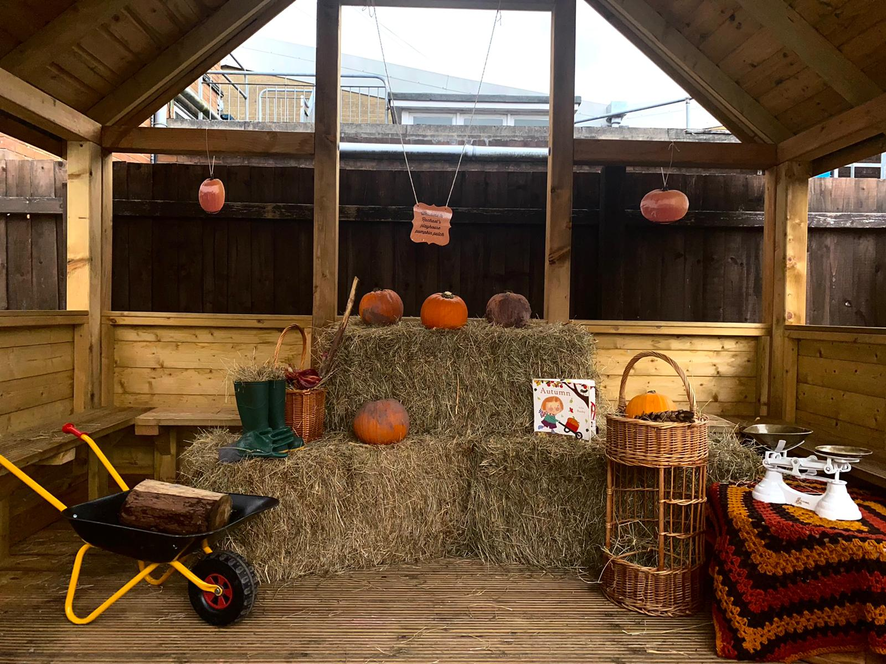
Hannah Jones and Rachael Barnett run successful childcare settings at Hirwaun and Aberdare for children aged from 18 months to 5 years old. Hannah explains how the Aberdare setting provides opportunities for learners from a young age to engage and connect with the natural environment.

“We have an allotment in which the children plant their own fruit and vegetables, we have free running water that the children can independently access at all times, a large mud kitchen and spaces in which the children can hide and build dens. We have an outdoor classroom; this ensures the children continue to have access to the outdoors whatever the weather. We have erected nest boxes, a wormery and a bug house, giving the children lots of opportunities to explore the natural world around them. Natural loose parts are available for the children to play with along with wheelbarrows and logs.

As we are based in a town centre, we are central to a lot of local nature areas. We walk them to local ponds, forests, large playing fields, farms, parks and rivers.
We often take learners out into the natural world. As a setting we plan in the moment. We find that most of our spontaneous learning is done in the natural environment. Most experiences that happen in the outdoor environment simply cannot be planned for. For example, we catch rain drops falling off the roof of the classroom and talk about gravity and measurements. We look at the shadows on the ground, wonder why they are in front of us and question where our shadow would be if we turned around. We relax, lie on the ground and watch the clouds move by, observing and discussing the different shapes that we see. The seasons are introduced naturally and explored hands on, all year round.

Whilst outdoors the children take part in risky play. This challenges them and supports their own self esteem as they learn to take risks, believe in themselves, and identify what they need to do to keep safe. The children hammer nails into tarpaulins to build dens, they roast potatoes in a fire pit, they climb ladders, and they jump obstacle courses they have built. These are just some examples of the risky play that is undertaken at the settings. Having access to such activities every day builds confidence, resilience, and problem-solving abilities. The children learn their own limitations and can identify their own risks. Our children are able to risk assess the play experience or activity independently.

We promote physical development, language and literacy in the environment by ensuring that children have access to resources such as pegs, chalk, cotton buds, tweezers, pipets, locks and keys and have threading opportunities with natural items. These are just some resources that develop the children’s fine motor skills and hand eye coordination. We have large and heavy items that the children can pull, carry, push and build with. These are fundamental to a child’s development as it is paramount the children have opportunities to work on the large upper muscles, as this in turn will help develop the smaller muscles in their hands and fingers. Allowing our children to access these freely gives them the opportunity to work on new skills, and revisit these, so that they become embedded.

It is sometimes thought that children are not focussing or concentrating if they are not sitting still however, young children are not meant to sit still for long periods of time, it goes against their body urges and requirements. From observing children in my settings, I can see that some children need to move and be physical in order to concentrate and be engaged in the learning taking place. Some children are able to participate in a higher level of sustained shared thinking if they are given the opportunity to move at the same time. Movement stimulates the brain. In fact, when children are given plenty of opportunities to move and be physical in the early years, they acquire the skills needed to sit still for periods of time when needed, such as when listening to a story. Physical activity is continuously promoted throughout our sessions. We believe that this is fundamental for children to become happy, healthy, and confident individuals. There is no more of a perfect environment for children to be active than the great outdoors. This is where children can climb trees, swing, jump, run, balance, build obstacle courses and so much more!”

Looking for learning resources, information or data? Please contact:
education@naturalresourceswales.gov.uk or go to https://naturalresources.wales/learning
Alternative format; large print or another language, please contact:
enquiries@naturalresourceswales.gov.uk
0300 065 3000

