December 2022

Enterprising, creative contributors - Penygarn pupils get ‘Arty Parky’

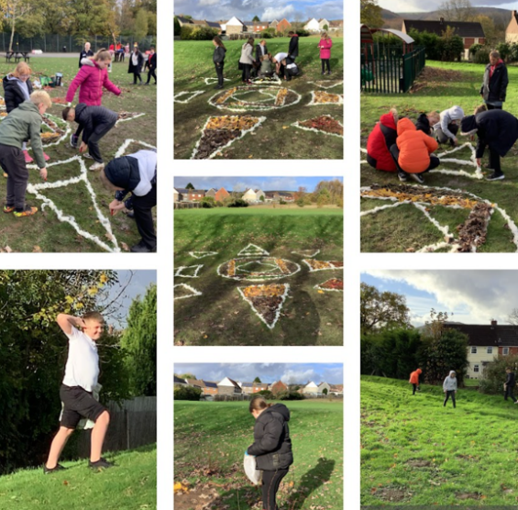
Having spent time exploring and taking notice of the natural beauty of their local natural environment, Years 4 and 6 pupils from Penygarn Primary, near Pontypool have been channelling their creative flair to create pieces of natural art.

In September, pupils from across Torfaen stepped up to a ‘Cariad Coed’ challenge set by Head4Arts during the ‘Big Green Week’, which is a UK-wide initiative that celebrates community action to tackle climate change and protect nature. As part of Cariad Coed, pupils completed 5 challenges which were designed to celebrate trees and wildlife. From creative writing and creating leaf and tree rubbings to tree dressing, pupils developed and extended their understanding and knowledge of the natural environment. Four schools completed the challenges - Penygarn, Griffithstown Primary, Pontnewydd Primary and Our Lady of the Angels Cwmbran and as a reward for their efforts, all were awarded with an ‘arty parky’ session at their school. We caught up with Penygarn Primary teacher, Donna Squirrel to learn what pupils had got out of their Arty Parky experience.

“With support from artists Kate Verity and Jordan Sallis from the Head4Arts team, pupils recently created a piece of land art. First, they laid out an outline using sheep’s fleece and then different classes from years 4 and 6 worked throughout the day to help fill in the shape with fallen natural materials. Leaves, twigs and seeds from the school grounds were sorted into piles based on their colour and shape. Different classes worked on specific sections and decided how the natural materials should be used to complete the drawing. The activity encouraged our learners to appreciate their natural environment and look at it from a new perspective whilst being out in the fresh air, connecting with nature and being creative. The children loved finding out about transient art and were inspired by the colours and changes in the season. They worked well together and were very proud of their artwork.”

Bethan Lewis, Assistant Creative Director at Head4Arts said “There was something special about the transient nature of pupils' artwork – it started to change almost as soon as it was finished (or even whilst it was being created when big gusts of wind blew through!) so pupils’ experience of it changed depending on when they viewed it. The natural materials used will eventually disperse and continue to have an ecological purpose. Wildlife may eat nuts or berries. Birds may use the fleece or twigs for nesting. Some people enjoyed watching how arty parky land drawings evolve over time – revisiting them a few days later after they have been created.”

“Creating an artwork in this way is a gentle introduction to the “arts” for those who do not consider themselves to be necessarily creative”, added Bethan. “It challenges them to think about what can be used as ‘art materials’ and helps to introduce the idea that art can be made from anything – you do not need specialised materials or equipment to be creative or to make something beautiful. Working in this way, encourages people to really look at the colour, shape and texture of leaves and other natural fallen materials. It was really nice creating a communal artwork where lots of pupils complete a small section of a larger piece.”

Established in April 2008, Head4Arts is a community arts organisation which operates in the South East Wales Valleys region, covering the county boroughs of Blaenau Gwent, Caerphilly, Merthyr Tydfil and Torfaen. Head4Arts work with people of all ages to provide high quality, inspirational art experiences that introduce participants to new art forms and unlock their creative potential. Their next regional project will be based around Earth Hour in March 2023, which will involve using creative activities to raise awareness of climate change and encourage participants to take positive action to reduce its effects.

Learning in, learning about and learning for our natural environment

Looking for learning resources, information or data? Please contact:
education@naturalresourceswales.gov.uk or go to https://naturalresources.wales/learning
Alternative format; large print or another language, please contact:
enquiries@naturalresourceswales.gov.uk
0300 065 3000

