December 2022

The ‘in-tree-ging’ learning opportunities a Christmas tree offers
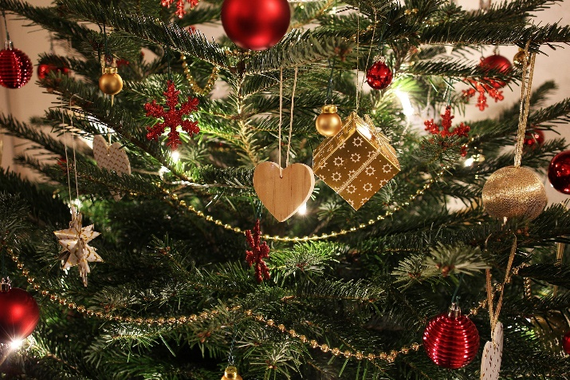
“It’s beginning to look a lot like Christmas” but have you ever stopped and wondered how evergreen trees, be they pine, spruce or fir, become the symbol of Christmas? Why do we cut down a perfectly good tree, drag it in the house and decorate it? Why not look into the origins of the custom with your learners? Evergreen trees have traditionally been used to celebrate winter festivals (Pagan and Christian) for thousands of years. Pagans used branches to decorate their homes during the winter solstice, as it made them think of the spring to come. Romans used fir trees to decorate their homes for the New Year. Christians see evergreens as a sign of everlasting life with God. Whatever its’ beginning, the Christmas tree is a symbol of hope during the cold, Christmas season.

Did you know that every year since 1947 the people of Norway have given the people of Britain a Christmas tree? This gift is in gratitude for Britain's support for Norway during World War II. Erected in Trafalgar Square each year, the Trafalgar Christmas tree is usually a Norwegian spruce which measures over 20 metres in height and is 50-60 years old. How does the Trafalgar Square Christmas tree compare with the trees we have in our houses in terms of height? How tall is the tree at your setting? How many miles does the tree fly to get from Oslo to London? Set your learners the task of finding out!

Do your learners have a plastic tree at home or a fresh Christmas tree? Real vs fake - it's a dilemma. Take it or ‘leaf’ it, in the cold ‘fairy light’ of day, a real Christmas tree takes about 7-10 years to grow and smells good. However, artificial trees are easy to assemble and store away. Why not set up a survey? You could ask your learners to take a deeper look into the pros and cons of each type. Hold a debate - what species makes the best Christmas tree? A nordmann fir is expensive, isn’t prickly to touch but has no scent! A Norwegian Spruce is more on the spikey side but is cheap in comparison with other species and gives a festive lovely scent!

Why not hold an experiment if you have more than one tree at your setting and ask your learners to make a hypothesis? Which species will be the first to drop its needles? How many litres of water does the tree need each day to save the carpet? So much potential…

The first Christmas tree was actually introduced to Britain in 1841 when Prince Albert, husband of Queen Victoria, decorated a large Christmas tree at Windsor Castle. Reminiscent of his childhood in Germany, decorating a Christmas tree had been a German tradition since the 18th century. Given the family-focused culture of the era, it wasn't long before Christmas trees became a key component of family holiday celebrations.

Learning in, learning about and learning for our natural environment

Looking for learning resources, information or data? Please contact:
education@naturalresourceswales.gov.uk or go to https://naturalresources.wales/learning
Alternative format; large print or another language, please contact:
enquiries@naturalresourceswales.gov.uk
0300 065 3000

